**RManager**

**Documentation**

**By Samuel Gresham and   
Harry Edmondson-Jones**

**Overview of Project**

RManager is a restaurant management tool which allows the user to create bookings, edit them and assign them to tables. The software then allows the user to view the bookings and allocations in the main screen.

**Allocation of Tasks**

Tasks were allocated based on overarching roles set at the beginning of the project. Harry would be involved in the graphical design and documentation of the project, while Sam would be directly involved in the implementation of the code as well as testing and maintenance.

**Harry**

1. Allocation of Tasks
2. Logbook
3. Gantt Chart
4. Screen Designs
5. Code Implementation
6. Graphic Design

**Sam**

1. Data Dictionary
2. Systems Flowchart
3. Data Flow Diagram
4. Structure Charts
5. Evaluating the Solution
6. Intrinsic/Internal Documentation
7. User Manual
8. Main Code Implementation

**Logbook**

Week 1:

During week one the Gannt chart was created with inclusion of all relevant documentation that will need to be completed. The dataflow diagram and structure charts were also drafted. Throughout the first week there were also various advancements in the code of the software, with the AdminLogin page being drafted and worked on throughout the week.

Week 2:

Throughout the second week the Gannt chart was finalised with the addition of additional tasks involved in the programming that is needed to be completed. In addition to this the structure chart and data flow diagram were also worked on throughout the week. Additionally, BoostrapCDN was added to the software to aid in the CSS and styling of the software.

Week 3:

In week 3 the Gannt chart has been completed and formatted fully. Similarly, to last week the structure chart and the data flow diagram was edited and updated to represent the constantly updating user interface. Furthermore, the AdminLogin page was completed allowing the user to create an account and also login with this account allowing them to access the rest of the software.

Week 4:

Throughout week 4 as the AdminLogin page has now been completed and the Main page has been created and has been worked on throughout the week. The structure chart and the data flow diagram have been updated to show the Main page and intrinsic documentation has been added to the AdminLogin page in the form of brief comments at the bottom of any relevant pieces of code. Screen designs have also been made to aid in explaining the AdminLogin page.

Week 5:

In week 5 the Main page has been updated so that clicking on the desired table will create a pop-up message displaying whether the table is reserved, your username and an option to close the pop-up message. Additionally, 3 buttons have been added to the Main page labelled, Create Booking, Manage Bookings and open register which don’t yet open any new pages, but will be coding in the future. The structure chart and dataflow diagram have also been updated to show the data passed between the login page to pop-up message, as it shows the username entered previously.

Holiday Weeks 1-2:

During the holiday weeks 2 other buttons were also added to the Main page in the software, labelled, “What is RManager?” and “Documentation”. The “What is RManager?” button displays a pop-up message giving a brief description of the aim of the software. The “Documentation” button, when clicked automatically downloads a word document for the user with all the documentation associated with the project.

Week 6:

During week 6 The documentation which is downloadable from the software, specifically there is now a brief description of what RManager is, The current progress which gives a description of what can be accomplished with the software. Alongside this future development goals which gives a few different goals that could be accomplished to further increase the productivity of the software.

Week 7:

Throughout week 7 there was more information added to the documentation, including, A brief user manual on how to login and create account. There was also instructions added on how to make a new booking and how to edit a new booking.

Week 8:

During week 8, there was more information added to the documentation. There was information added about what external libraries were added when creating the code and why they were used, specifically, JQuery, Bootstrap and Sweetalert. Furthermore the Home page was edited slightly and finished for now so that we can move onto the “create booking” and “Manage Booking” pages.

Week 9:

In week 9 the main goal was to make an effort on making the “make booking” and “Manage Booking” pages which was accomplished. Throughout the week there were various advancements in the code of the software. In the “create booking” page 3 drop down boxes have been made to choose the amount of people, time and type of table wanted when creating a booking. In the “Manage Booking” page a few different headings were made so that when completed the user will be able to chose the booking they want to manage and look at the, Booking name, date, time and location.

Week 10:

During week 10 the “Create booking” and “Manage booking” page were worked on similar to the previous weeks. Throughout week 10 there was a create booking button added to the “create booking” page which if all the information is filled out on the page will save the booking to storage. The Structure chart and data flow diagram were also updated as they have not been updated for a while.

Week 11:

Week 11 was mainly used to develop updates for the manage bookings page which will now give the user the option to search for a specific booking and if found, erase the booking, or edit the bookings details.

Week 12:

During Week 12 the Manage booking page was further updated to make it easier to search for booking and gives the user the ability to click on the “More Booking Queries” button which opens up another window allowing the user to enter a date and time for which the software will reply with all the bookings scheduled for the date and time that have been entered.

Week 13:

In week 13 the main goal was to completely finish the “Create booking” page and “manage booking” pages. On the “create Booking” page there was another button added which allowed the user to go back and discord the current booking being created instead of the user having to manually delete all the text and then click to go back a page which was tedious.

Week 14:

Week 14 is the week that the “Open register” page was supposed to be started according to the plan outlined on the Gannt chart created at the start of the project, but before this was started there were a few minor adjustments made to the “create booking” page, including, font size adjustment and spacing. After this the “open register” page was started. During the week there were 6 main buttons created on the page including 6 possible items that the customer could order. Additionally in week 14 the system flowchart was completed for all of the software so far.

Holidays weeks 3-5:

During the holidays there were a number of changes made in the software and the documentation. On the main page there was another button added labelled “Assign a table” Which allowed the user to open a new page allowing the user to search for all of the bookings and also assign bookings to a specific table. The “open register” page was also updated so that clicking on a button will order that item and the price of that item will be added to the table desired. There was also an option add the total of all the items purchased and generate a bill for a table. Additionally the screen designs have been finished for the software and the structure chart and data flow diagram have also been completed.

Week 15:

As the project is coming to a finish soon there isn’t too much work left to do besides tidying up pieces of code. In week 15 there was a small update allowing the user to change the date and time for the software.

Week 16:

In week 16 all the font were updated so that the titles are more clear and obvious the settings page was also fully completed with an additional button added to let the user set the date to today. Week 16 was also used to complete the system flowchart

Week 17:

During week 17 the data dictionary was completed, with all the relevant data. The Evaluation was also started.

Week 18:

Week 18 was the deadline for the project and the main goal of the first part of the week before it is due is to evaluate the project which was accomplished.

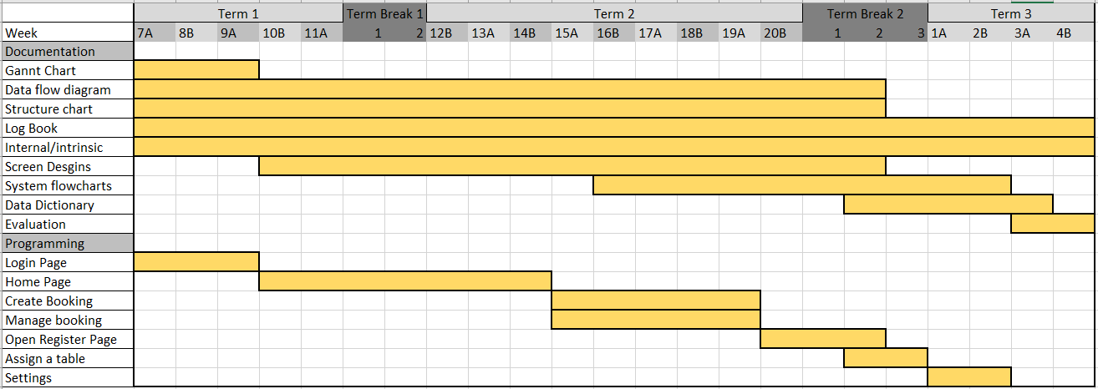**Gantt Chart**